Project Design Phase-II
Technology Stack (Architecture & Stack)
Date | 29 September 2026
Team ID | SWTID-2026-7644
Project Name | Script-Controlled ACL – Restrict Record Access Based on Field Value
Maximum Marks | 4 Marks
Technical Architecture:
The deliverable shall include the architectural diagram as below and the information as per Table-1 & Table-2.
Example: Script-Controlled ACL Architecture
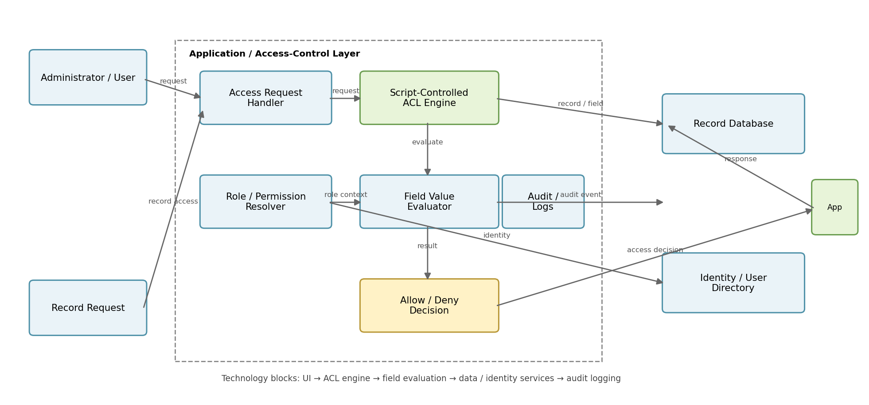
Guidelines:
• Include all the processes as application logic / technology blocks.
• Provide infrastructure demarcation between application, data and external services.
• Indicate external interfaces such as identity or third-party services when applicable.
• Indicate data storage components / services.
• Indicate interfaces used for authentication, authorization and audit logging.

Table-1 : Components & Technologies
S.No | Component | Description | Technology
1. | User Interface | How administrator / user interacts with the application. | HTML, CSS, JavaScript / React JS or existing application UI
2. | Access Request Handler | Receives record access requests and passes user and record context to the ACL engine. | Application server / ServiceNow server-side logic
3. | Script-Controlled ACL Engine | Evaluates authorization logic before allowing access to a record. | ACL + Server-side Script
4. | Field Value Evaluator | Reads the selected record field and compares it with the permitted value. | JavaScript / Platform scripting
5. | Role / Permission Resolver | Identifies user roles and permitted field values. | Application roles / Identity & access rules
6. | Record Database | Stores records and the field values used for access decisions. | Relational / Platform Database
7. | Audit / Access Log | Stores access decisions and relevant audit information. | Application Audit Log / Database
8. | Identity / User Directory | Provides user identity, roles and authentication context. | User Directory / IAM
9. | Infrastructure | Hosts the application, ACL processing and data services. | Local Server / Cloud Platform
10. | Monitoring | Tracks errors, denied requests and system health. | Application Logs / Monitoring Service

Table-1 : Components & Technologies (continued)
S.No | Component | Description | Technology
11. | Security Controls | Least-privilege access, secure scripting and protection of restricted records. | ACL Rules, Role-based Access Control, Secure Coding
12. | Configuration Store | Stores configurable field names, permitted values and rule settings. | Application Configuration / Database
13. | Testing Layer | Validates allow and deny scenarios for different users and field values. | Unit / Functional Test Cases
14. | Deployment | Publishes ACL scripts, configurations and application changes. | Version Control / Deployment Pipeline
Table-2 : Application Characteristics
S.No | Characteristics | Description | Technology
1. | Open-Source / Platform Frameworks | List the frameworks or platform components used to implement the ACL and application logic. | JavaScript / Platform ACL framework
2. | Security Implementations | List security controls such as authentication, authorization, least privilege and audit. | RBAC, ACL, IAM, Secure Coding
3. | Data Protection | Protect restricted records and prevent unauthorized field-value exposure. | Database permissions, ACL checks, encryption where applicable
4. | Logging & Auditing | Record important access attempts, decisions and configuration changes. | Audit Logs / Application Monitoring

Table-2 : Application Characteristics (continued)
S.No | Characteristics | Description | Technology
5. | Scalable Architecture | Support increasing users, records, roles and field values without major redesign. | Modular ACL logic, scalable application/database
6. | Availability | Access-control processing should remain available whenever the application is available. | Application redundancy / platform availability
7. | Performance | Field-value evaluation should add minimal delay to normal record retrieval. | Efficient scripts, indexed fields, optimized queries
8. | Maintainability | Rules and scripts should be easy to test, update and audit when requirements change. | Version Control, modular scripts, test cases
9. | Compatibility | The solution should work with the existing application and identity model. | Existing application APIs / IAM integration
Technology Stack Summary
The solution uses a script-controlled ACL layer between the user request and record data. The ACL engine evaluates the user's role and the selected record field value, then returns an Allow or Deny decision. Audit logging, identity services, secure configuration and testing support reliable field-based access control.
References
https://www.ibm.com/cloud/architecture
https://aws.amazon.com/architecture/
https://developer.ibm.com/patterns/
https://owasp.org/www-project-top-ten/

